Immigration/Migration Study Guide

Key Terms & People

Middle Passage
Manifest Destiny
Old Immigrants
New Immigrants
Pacific Railway Act
College Land Grant Act
Homestead Act
Trail of Tears
Great Migration
Chicago Defender
Irish Exodus
Treaty of Guadalupe
Gadsen Purchase
Louisiana Purchase
Northwest Passage
Horatio Alger Myth
Great Depression
Dime Novel
New Deal
Tenement
Ellis Island
Dawes Act
Chinese Exclusion Act
Immigration Act (1924)
USA PATRIOT Act

Puritans
John Winthrop
Cotton Mather
Thomas Jefferson
Andrew Jackson
Lewis Cass
Ethan Allen Hitchcock
Abraham Lincoln
Black Hawk
Tecumseh
John Ross
Zachary Taylor
Robber Barons
Sitting Bull
John Steinbeck
Emma Lazarus
Franklin D. Roosevelt
Richard Wright
John Steinbeck
Dorothea Lange
Bill Clinton
George W. Bush

Key Readings
Zinn: chapters: 1, 2, 7, 8, 11, 24 (discussed in the last unit)
History of Immigration 1850s-Present; additional packets
Selections from Richard Wright’s Black Boy
John Steinbeck, Grapes of Wrath (chapter 17)

Theme
Is immigration/migration across borders a human right?

Subthemes
- How did Manifest Destiny play a role in the expansion of the United States?
- What actions did the government take to encourage U.S. expansion?
- What challenges and successes did immigrants and minorities face throughout the 19th and 20th centuries?
- What role did class/racial conflict play in U.S. immigration/migration?
- How can we use the past to understand our current dilemmas with immigration?

Skills
For this exam you should be able to:
- Demonstrate a geographic understanding of colonial and U.S. expansion
- Understand the general timeframe of events discussed in the Immigration/Migration unit
- Analyze and interpret political cartoons about immigration/migration
- Analyze and primary sources about immigration/migration
- Analyze and interpret art and photographs about immigration/migration
- Analyze and charts and data about immigration/migration
Key Questions
- How did early colonial settlers impact American thought regarding immigration?
- The U.S. doubled in size following the Louisiana Purchase. What rights, if any, did Native Americans have to the land? What was the product of U.S. expansion on Native American groups (be sure to include specific people, places, events and dates in your response)?
- Describe the points of view of those who opposed the Mexican War and those who supported the Mexican War. Using evidence from the text, as well as additional sources, which side do you think provided the best argument?
- In what ways did new immigrants contribute to American society in the late 19th/early 20th centuries? How were their efforts rewarded?
- Describe the key reasons for people migrating within the United States. What were the causes and effects of their migrations?
- What are the similarities and differences between the immigration debates in the late 19th/early 20th centuries and the debates raging today?
- What should the U.S. immigration policy be for the 21st century?

Review Questions
Is movement across borders a human right? Please justify your answer.

Examine the three cartoons to answer the questions below.
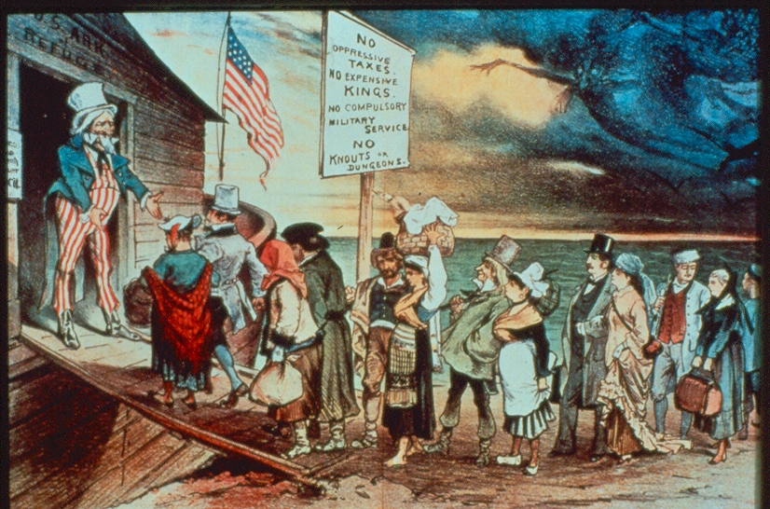

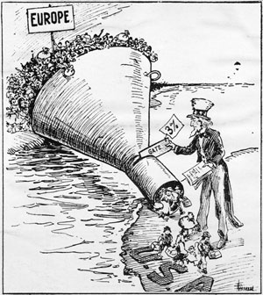
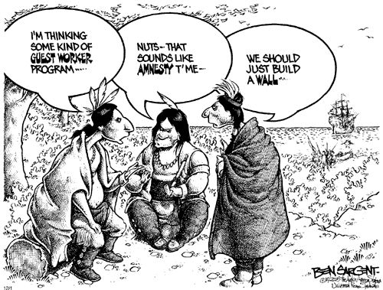

- Describe the people you see in cartoons 1 and 2. Do you see any similarities? Any differences? If so, describe them.
- Describe cartoon number 3. Who is present? What are they debating? Does the cartoon tie into any immigration issues today?

